IBEC & ICMS EXCHANGE PROGRAM
CALL FOR APPLICATIONS
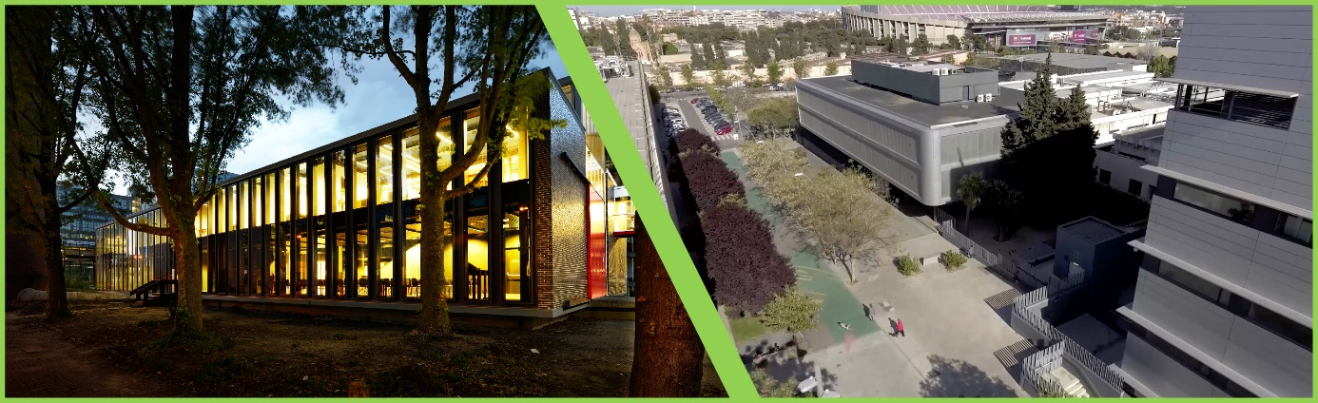

ICMS and IBEC strive to grow research talent in the fields of organ-on-a-chip, regenerative medicine, tissue engineering, chemical biology, biomaterials, imaging and nano-biotechnology. Therefore, we are pleased to invite IBEC postdocs, PhD and Master Students to apply for funds to visit ICMS and expand their expertise and network.
The Program is funded by the Spanish Ministry of Science, Innovation and Universities through the Centro de Excelencia Severo Ochoa Award

CALL INFORMATION
Who can apply?
IBEC Postdocs, PhD’s and Master students
How many calls will there be?
ICMS and IBEC calls are continuously open for submitting proposals within this exchange program
Budget 2023:
8000 €
What can be applied for?
Travel and/or accommodation costs to visit for a maximum of 3 months.
- Postdocs and PhD’s can apply for a maximum of 2000 €
- Master Students can apply for a maximum of 1000 €
Deadlines:
Call for Applications is continuously open, proposals will be evaluated after 3 cut-off dates submission of proposals:
- 15th March 2023
- 15th May 2023
- 15th September 2023
GENERAL INFORMATION

- This Call for Applications aims to:
  - provide researchers the opportunity to experience the excellent ICMS research environment.
  - enable researchers to strengthen their research by adding complementary ICMS expertise and/or infrastructure to their research principles and/or concepts.
- Call for applications is continuously open. Proposals will be evaluated 3 times per year
- These funds can be combined with other funds (compatible with other funding instruments) as long as there is no double funding for the same cost.
- The proposed research may be part of a larger project or connected to a conference
- ICMS and IBEC may request the student involved in the program to participate in knowledge dissemination activities such as websites, newsletters, seminars, social media and workshops.
- Awardees must submit a short summary to report on the research outcomes at the end of the exchange (to be submitted a maximum of 2 weeks after completion of the exchange period).
- The receiving organization can require the applicant to complete a guest declaration and a confidentiality agreement.

WHO IS ELIGIBLE TO APPLY?
- Postdocs, MSc and PhD students can apply for funding to facilitate a visit to ICMS. This funding is intended to cover travel and/or housing costs for the researchers during their stay at the receiving organization.
  - Postdocs and PhD students can apply for:
    - A max. amount of 1000 € per month
    - Funds are available for a period of up to 3 months
    - The total application amount cannot exceed 2000 €
  - MSc students can apply for:
    - A max. amount of 500 € per month
    - Funds are available for a period up to 3 months
    - The total application amount cannot exceed 1000 €
- Any one individual can only be awarded funding once per year.

EVALUATION OF THE APPLICATIONS
The applications will be evaluated by the ICMS and IBEC boards (if required, experts in the field will be consulted to aid in the decision-making process). The selection criteria which will be taken into account by the selection panel are:
- The scientific quality of the proposed research activities at the receiving organization.
- The uniqueness and complementarity of the proposed activities at the receiving organization. The activities which are proposed should not be feasible at the sending organization or if there is a justified added value in the proposed research.
- The end date of the submitted proposal should not exceed the end date of the contract of the applicant. Only if the student has a signed agreement to continue working for the sending organization then the student is eligible for receiving this funding.

HOW TO APPLY?

To apply for funding within the IBEC & ICMS exchange program, please complete the Application Form on the following page.
It is mandatory, prior to submission, to have the agreement of both the sending and the hosting research group. Please cc the research supervisors of both the sending and the receiving organization when submitting the request for funding.

CONTACT:

IBEC researchers can submit their application at: international@ibecbarcelona.eu

The Application Form can be found on the following page.

APPLICATION FORM

Researcher
Name:
Organization:
Contact details:
End date of contract or internship:
Requested period for the visit at the receiving institution (start-end dates):

Supervisor at the receiving organization
Name:
Organization:
Contact details:

Duration of the stay (in months):
Requested budget:
Purpose for the requested budget (max. ½ A4):
Is this a stand-alone project or is this part of a bigger project or connected to a conference?
Is there any additional funding for this trip (if yes, please specify source and amount)?

Research proposal (max. 1 page with margins 2.5 cm in Verdana font size 8; max. 1100 words)
- Motivation of the visit:
Please include the reason why a visit to IBEC or ICMS is needed to perform research activities
- Research Activities
Please describe research activities which will be executed at the receiving organization(incl. aim, novelty, experiments, expected outcome, etc.)
- Requested Budget

Researcher
Name:
Date:
Signature:

